Dear Vendor:
Creative Party Representative and Speak To Me have come together to bring you the most awesome event. We cordially invite you to participate in the 2nd annual Moms and Mimosas Mothers in Unity Extravaganza as a vendor. The event will be held on Saturday, May 3, 2014 from 12:00pm until 4:00pm at The Hernando Hideaway, 3210 Old Hernando Rd. Memphis, TN 38116. This is an event to celebrate all of the mothers around the city. We want to show them how much they are loved & appreciated by hosting this awesome event!! Brunch Buffet, massages, facials, vendors, fashion show and much much more! We want you to help make this a spectacular event! As a vendor, you will help customers find gifts for a mom they may know or just find useful services that could be used in the future. You can sell your items or do a few giveaways. The choice is yours!
Booth rental is $30. You will keep all of your proceeds from the day. Payment can be made in the form of cash, money order or PayPal. I will bill you through PayPal but you can specify if you want to use an alternate payment method. You will be provided a space to set up your products/services. If you need us to provide a table for you, it is an extra $10 fee. Please specify your needs on the vendor application. You can begin setting up your booth as early as 10:00am. Please have your booth area set up no later than 11:30am so everything will ready for the event to begin on time.
We are asking all vendors to promote the event to friends, family, coworkers, etc through all social media networks as well as flyers. Once you have turned in your application and fee, we will make you a host on Facebook to invite people you know. If you need tickets to sell, please let us know ASAP. You must return all unsold tickets to us the day of the event. If you do not, you will forfeit your booth space. The vendor that sells the most tickets will receive a refund on their booth space.
We are looking forward to working with you. Your participation in the event will allow it to become a great success. Thank you in advance for your participation. Please complete the enclosed application and return it to one of the names and addresses below or scan it in as an email. When your application and payment are received, we will notify you to let you know that a space has been reserved. We will not hold any spaces without payment, NO EXCEPTIONS! Applications are received on a first come basis. Vendor space is limited, so please get your fee and application in TODAY!
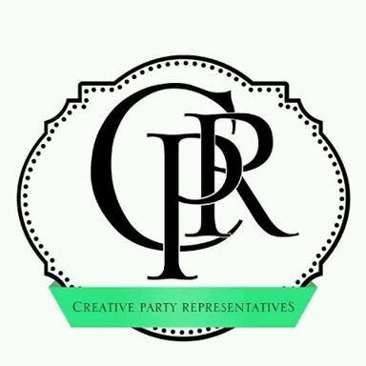
Again, thank you for participating in this event!
Shay Bond Jeanine Jones
Creative Party Representative Founder
www.creativepartyrep.com www.speaktomebooks.com
901-315-3269 901-240-1527
4998 Darlington Drive
Memphis, TN 38118

